

MICRO CREDIT PROJECT

Submitted by:

ABHISHEK PAI

**ACKNOWLEDGMENT**

The Dataset and related information was provided by Flip Robo as part internship phase. This entire file package included a dataset with is column understanding to help with project analysis. Furthermore, guidance was provided by staff mentors in Flip Robo through doubt-solving sessions and tickets. Few code-related help and structure-related understanding was been taken from sources available on the internet.

**INTRODUCTION**

* Business Problem Framing

A Microfinance Institution (MFI) is an organization that offers financial services to low-income populations. MFS becomes very useful when targeting especially the unbanked poor families living in remote areas with not many sources of income. The Microfinance services (MFS) provided by MFI are Group Loans, Agricultural Loans, Individual Business Loans, and so on.

Many microfinance institutions (MFI), experts, and donors are supporting the idea of using mobile financial services (MFS) which they feel are more convenient and efficient, and cost-saving, than the traditional high-touch model used long to deliver microfinance services. Though the MFI industry is primarily focusing on low-income families and is very useful in such areas, the implementation of MFS has been uneven with both significant challenges and successes.

Today, microfinance is widely accepted as a poverty-reduction tool, representing $70 billion in outstanding loans and global outreach of 200 million clients.

We are working with one such client that is in Telecom Industry. They are a fixed wireless telecommunications network provider. They have launched various products and have developed their business and organization based on the budget operator model, offering better products at Lower Prices to all value-conscious customers through a strategy of disruptive innovation that focuses on the subscriber.

They understand the importance of communication and how it affects a person’s life, thus, focusing on providing their services and products to low-income families and poor customers that can help them in the need of the hour.

They are collaborating with an MFI to provide micro-credit on mobile balances to be paid back in 5 days. The Consumer is believed to be a defaulter if he deviates from the path of paying back the loaned amount within the time duration of 5 days. For the loan amount of 5 (in Indonesian Rupiah), the payback amount should be 6 (in Indonesian Rupiah), while, for the loan amount of 10 (in Indonesian Rupiah), the payback amount should be 12 (in Indonesian Rupiah).

.

* Conceptual Background of the Domain Problem

Going through the project background it seems to be a classification problem. Classification is a data mining function that assigns items in a collection to target categories or classes. The goal of classification is to accurately predict the target class for each case in the data.

Building a model which can be used to predict in terms of a probability for each loan transaction, whether the customer will be paying back the loaned amount within 5 days of insurance of loan. In this case, Label ‘1’ indicates that the loan has been paid i.e. Non- defaulter, while, Label ‘0’ indicates that the loan has not been paid i.e. defaulter.

* Review of Literature

There is not much research performed as the Data and related information was provided by the source itself, which was been taken into consideration based on the information given by Flip Robo.

* Motivation for the Problem Undertaken

The Project was assigned by flip Robo as part of the internship phase for better understanding the concept and getting the idea of the industry.

**Analytical Problem Framing**

* Mathematical/ Analytical Modeling of the Problem

After importing data various analyses were performed which had univariate, bivariate, and multivariate analysis.

Univariate analysis:Univariate analysis is the simplest form of analyzing data. It doesn't deal with causes or relationships and its major purpose is to describe; It takes data, summarizes that data, and finds patterns in the data.

Bivariate anslysis:Bivariate analysis is one of the simplest forms of quantitative analysis. It involves the analysis of two variables, to determine the empirical relationship between them. Bivariate analysis can help test simple hypotheses of association.

Multivariate analysis: Multivariate statistics is a subdivision of statistics encompassing the simultaneous observation and analysis of more than one outcome variable. Multivariate statistics concerns understanding the different aims and background of each of the different forms of multivariate analysis, and how they relate to each other.

Outliers and Skewness: Outlier Analysis is a process that involves identifying the anomalous observation in the dataset.Skewness measures the deviation of a random variable's given distribution from the normal distribution, which is symmetrical on both sides. Both were done to bring data in a good shape

* Data Sources and their formats

The Dataset and related information was provided by Flip Robo as part internship phase. The zip file included A **CSV** (comma-separated values) file, a text file, an MS EXCEL file, and two MS WORD files.

* Data Preprocessing Done

After loading the data the information of data was been checked and a five-row sample was been observed.

Later after performing analysis on the dataset, the Outlier and skewness of data was been removed.

Feature engineering was been performed based on the requirement.

Some features were not necessary for ML and were dropped before model building

* Data Inputs- Logic- Output Relationships

The entire data was in form of CSV and was a mixture of numbers, and objects. The output variable is information in a pattern of 1 and 0 each having its significant meaning. The output was based on the data which was provided by a source on the behavioral pattern of the entity. The object part was been converted and extracted to perform ML

* Hardware and Software Requirements and Tools Used

The system with a 16 core processor was been used,

The operating system was Windows 10,

Anaconda 3 was been used for performing ML

Libraries: import numpy as np

import pandas as pd

import seaborn as sns

matplotlib

matplotlib.pyplot as plt

plotly.express as px

sklearn.metrics import classification_report

scipy.stats import skew

sklearn.preprocessing import power_transform

sklearn.ensemble import RandomForestClassifier

sklearn.ensemble import XGBClassifier

sklearn.ensemble import GradientBoostingClassifier

sklearn.tree import DecisionTreeClassifier

sklearn.metrics import accuracy_score

sklearn.preprocessing import power_transform

sklearn import metrics

sklearn.metrics import roc_auc_score

sklearn.metrics import accuracy_score,confusion_matrix,f1_score,mean_squared_error,roc_curve,precision_recall_curve

sklearn.model_selection import train_test_split

warnings

**Model/s Development and Evaluation**

* Identification of possible problem-solving approaches (methods)

Performing univariate bivariate and multivariate analysis helped a lot to understand the nature of data-based, also performing outliers check and skewness helped to shape data, based that the data was scaled and then principal component was performed.

* Testing of Identified Approaches (Algorithms)

There were 4 algorithms used.

* RandomForestClassifier
* XGBClassifier
* GradientBoostingClassifier
* DecisionTreeClassifier

* Run and Evaluate selected models

RandomForestClassifier:

Before tuning

Accuracy_Score: 0.9663362378360697

roc_auc_score: 0.9662067444755146

After tuning

Accuracy_Score: 0.8517340699079584

roc_auc_score: 0.8516451928321143

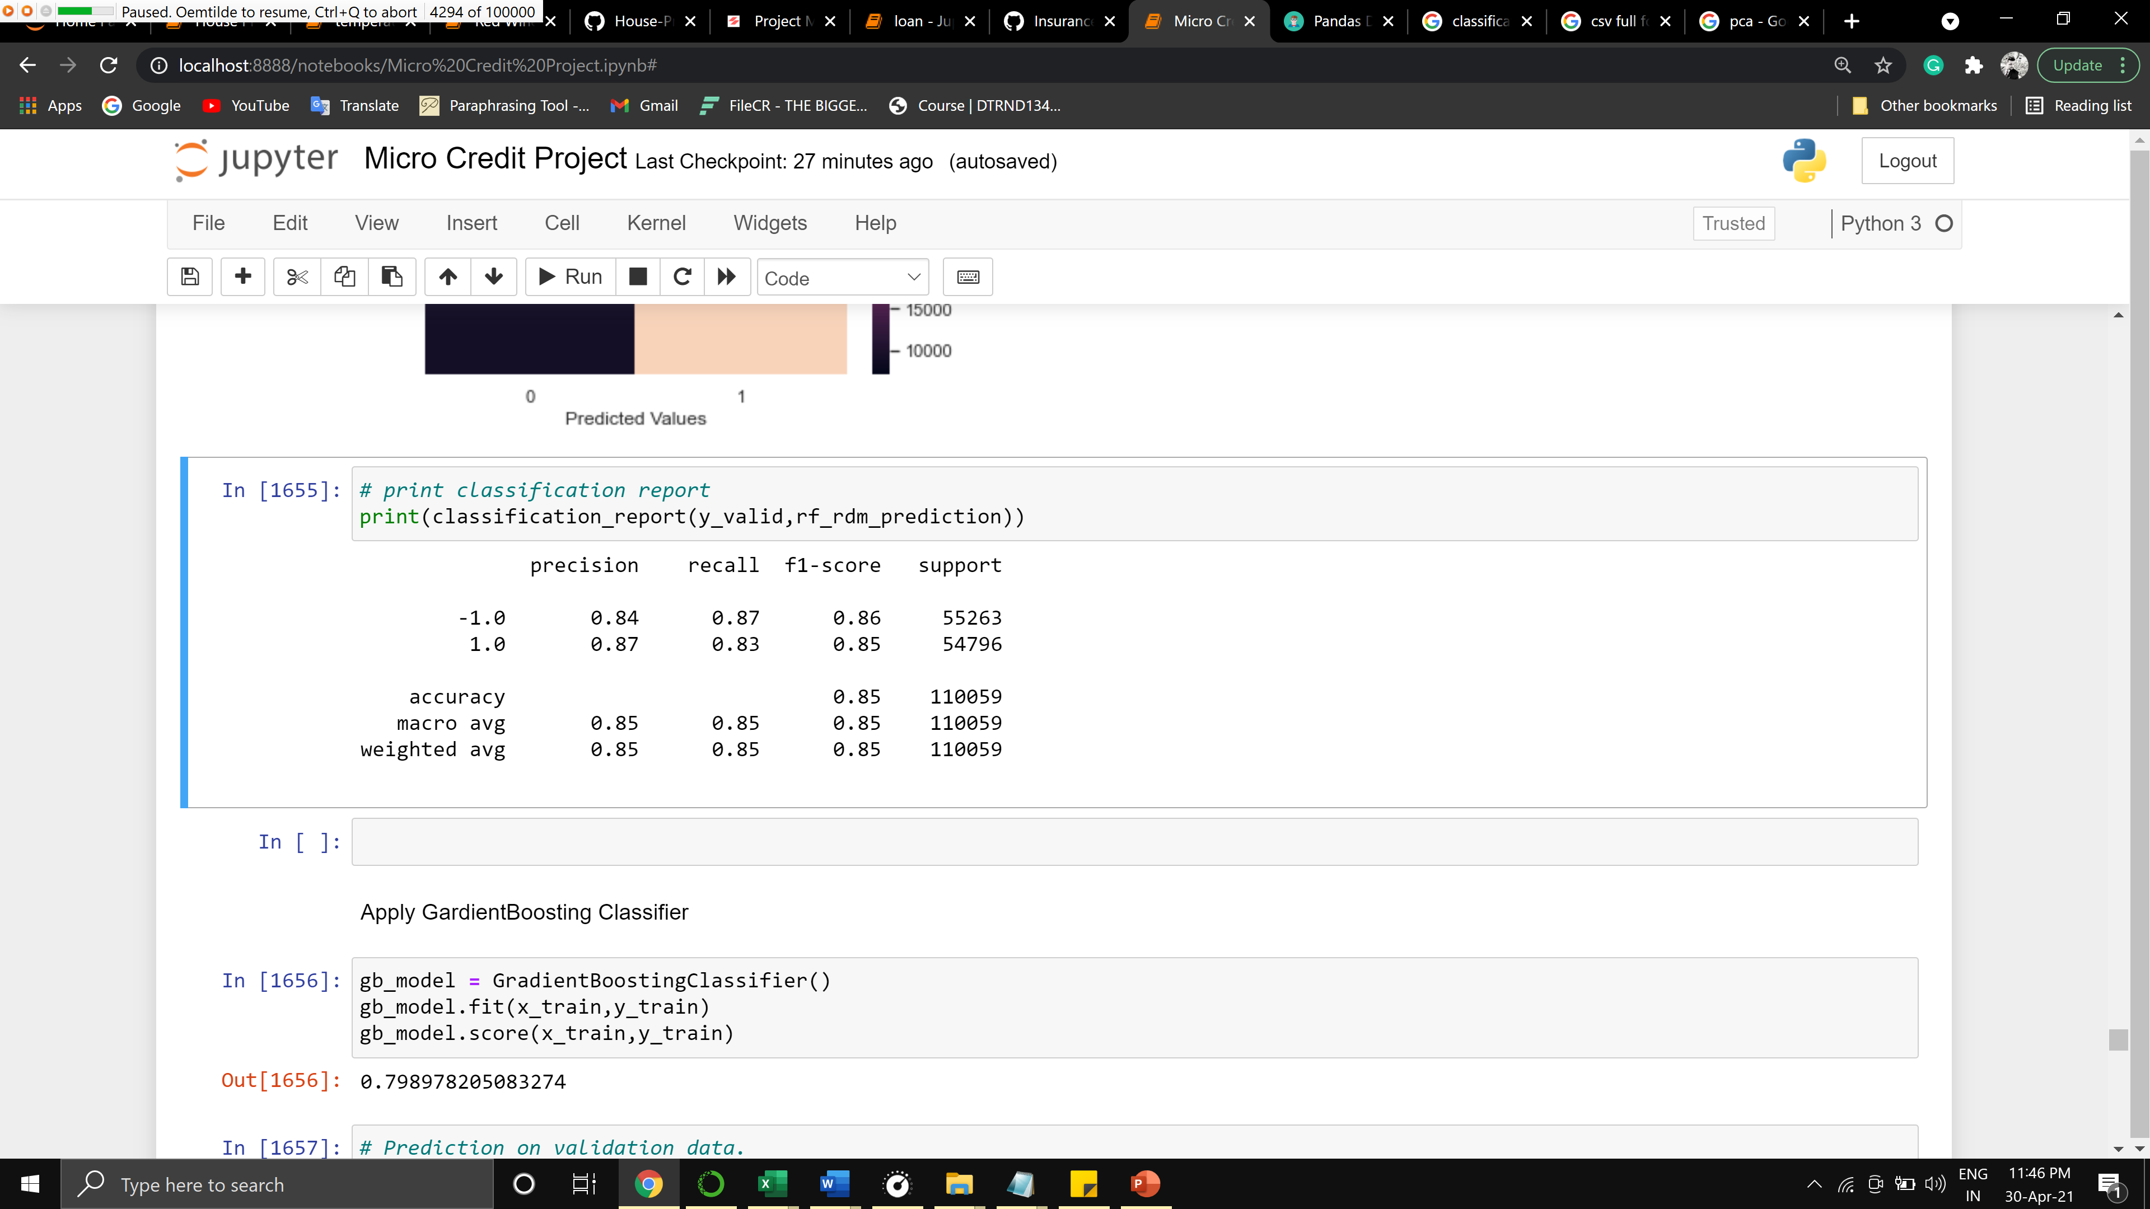

The accuracy of the algorithm has been reduced after tuning

GradientBoostingClassifier

Before tuning

Accuracy_Score: 0.7997892039724148

roc_auc_score: 0.7997975124985397

After tuning

Accuracy_Score: 0.9402047992440419

roc_auc_score: 0.9399974182212741

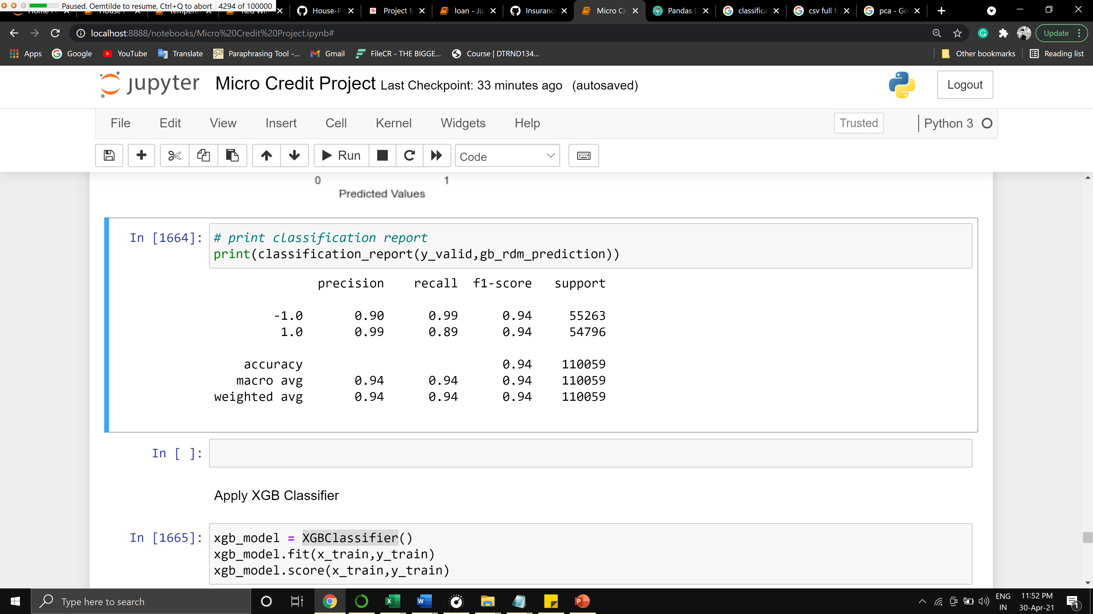

The accuracy of the matric was increased though it didn’t perform as good as XGB

XGBClassifier

Before tuning

accuracy_Score: 0.8483994948164166

roc_auc_score: 0.8482806780676397

After tuning

Accuracy_Score: 0.9627018235673593

roc_auc_score: 0.962557228566522

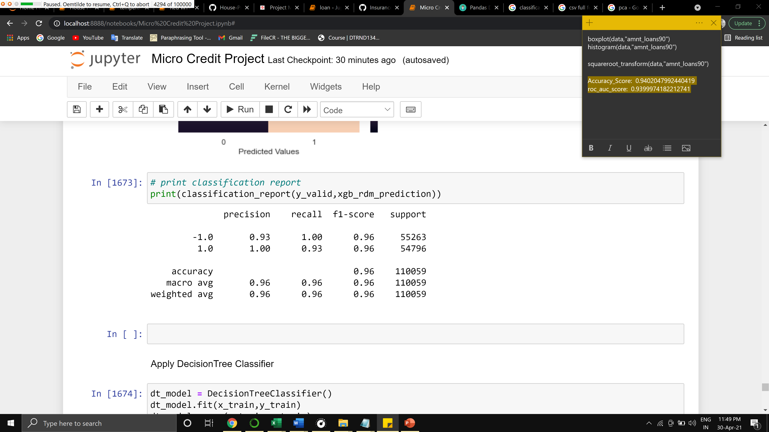

The performance of this algorithm was extremely good compared to other algorithms

DecisionTreeClassifier

Before tuning

Accuracy_Score: 0.9467830890704076

roc_auc_score: 0.9465699662252651

After tuning

Accuracy_Score: 0.8067763654040105

roc_auc_score: 0.8066313147989352

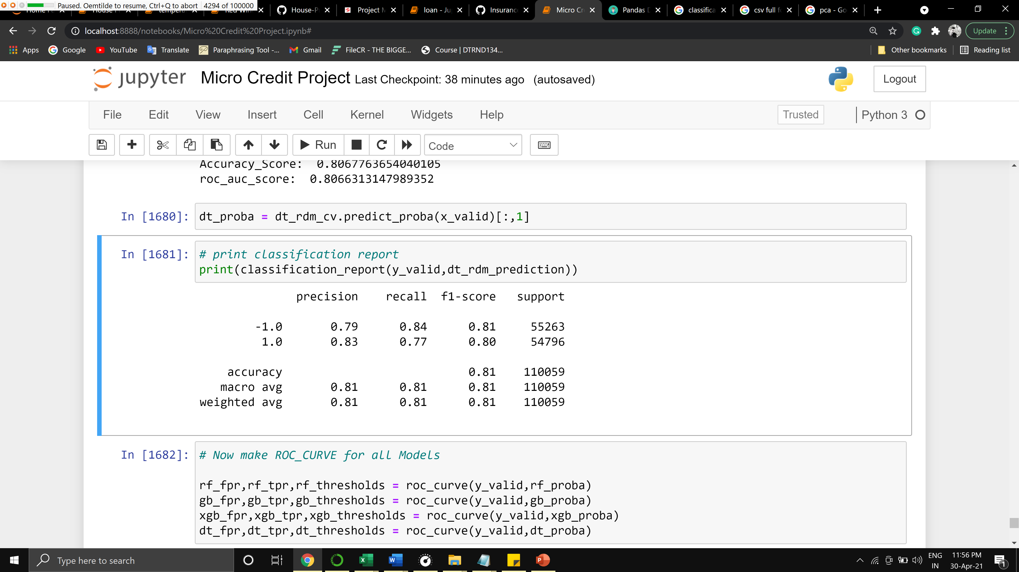

The performance of this metric harshly fell after tuning so it is not ideal for our project

* Key Metrics for success in solving the problem under consideration

There were 3 key performance metrics used, i.e F1 score, the Accuracy score

Accuracy is used when the True Positives and True negatives are more important while F1-score is used when the False Negatives and False Positives are crucial. Accuracy can be used when the class distribution is similar while F1-score is a better metric when there are imbalanced classes as in the above case.

* Visualizations

Univariate analysis

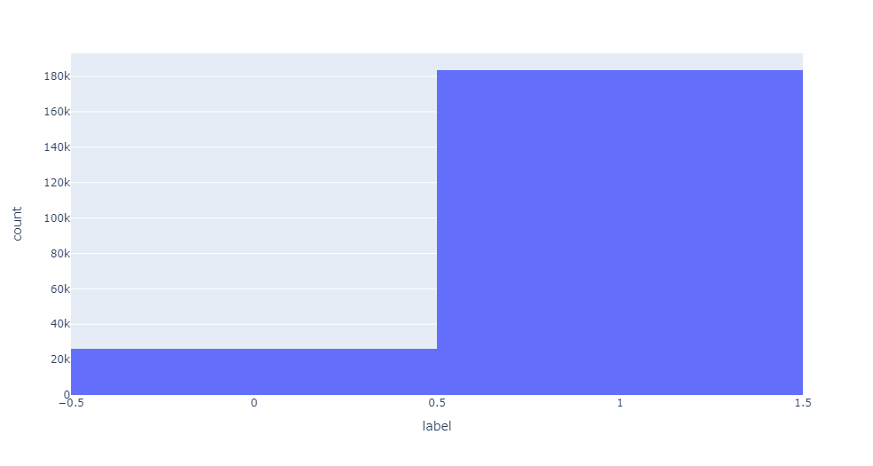

Understanding the nature of the label which seems to be imbalanced

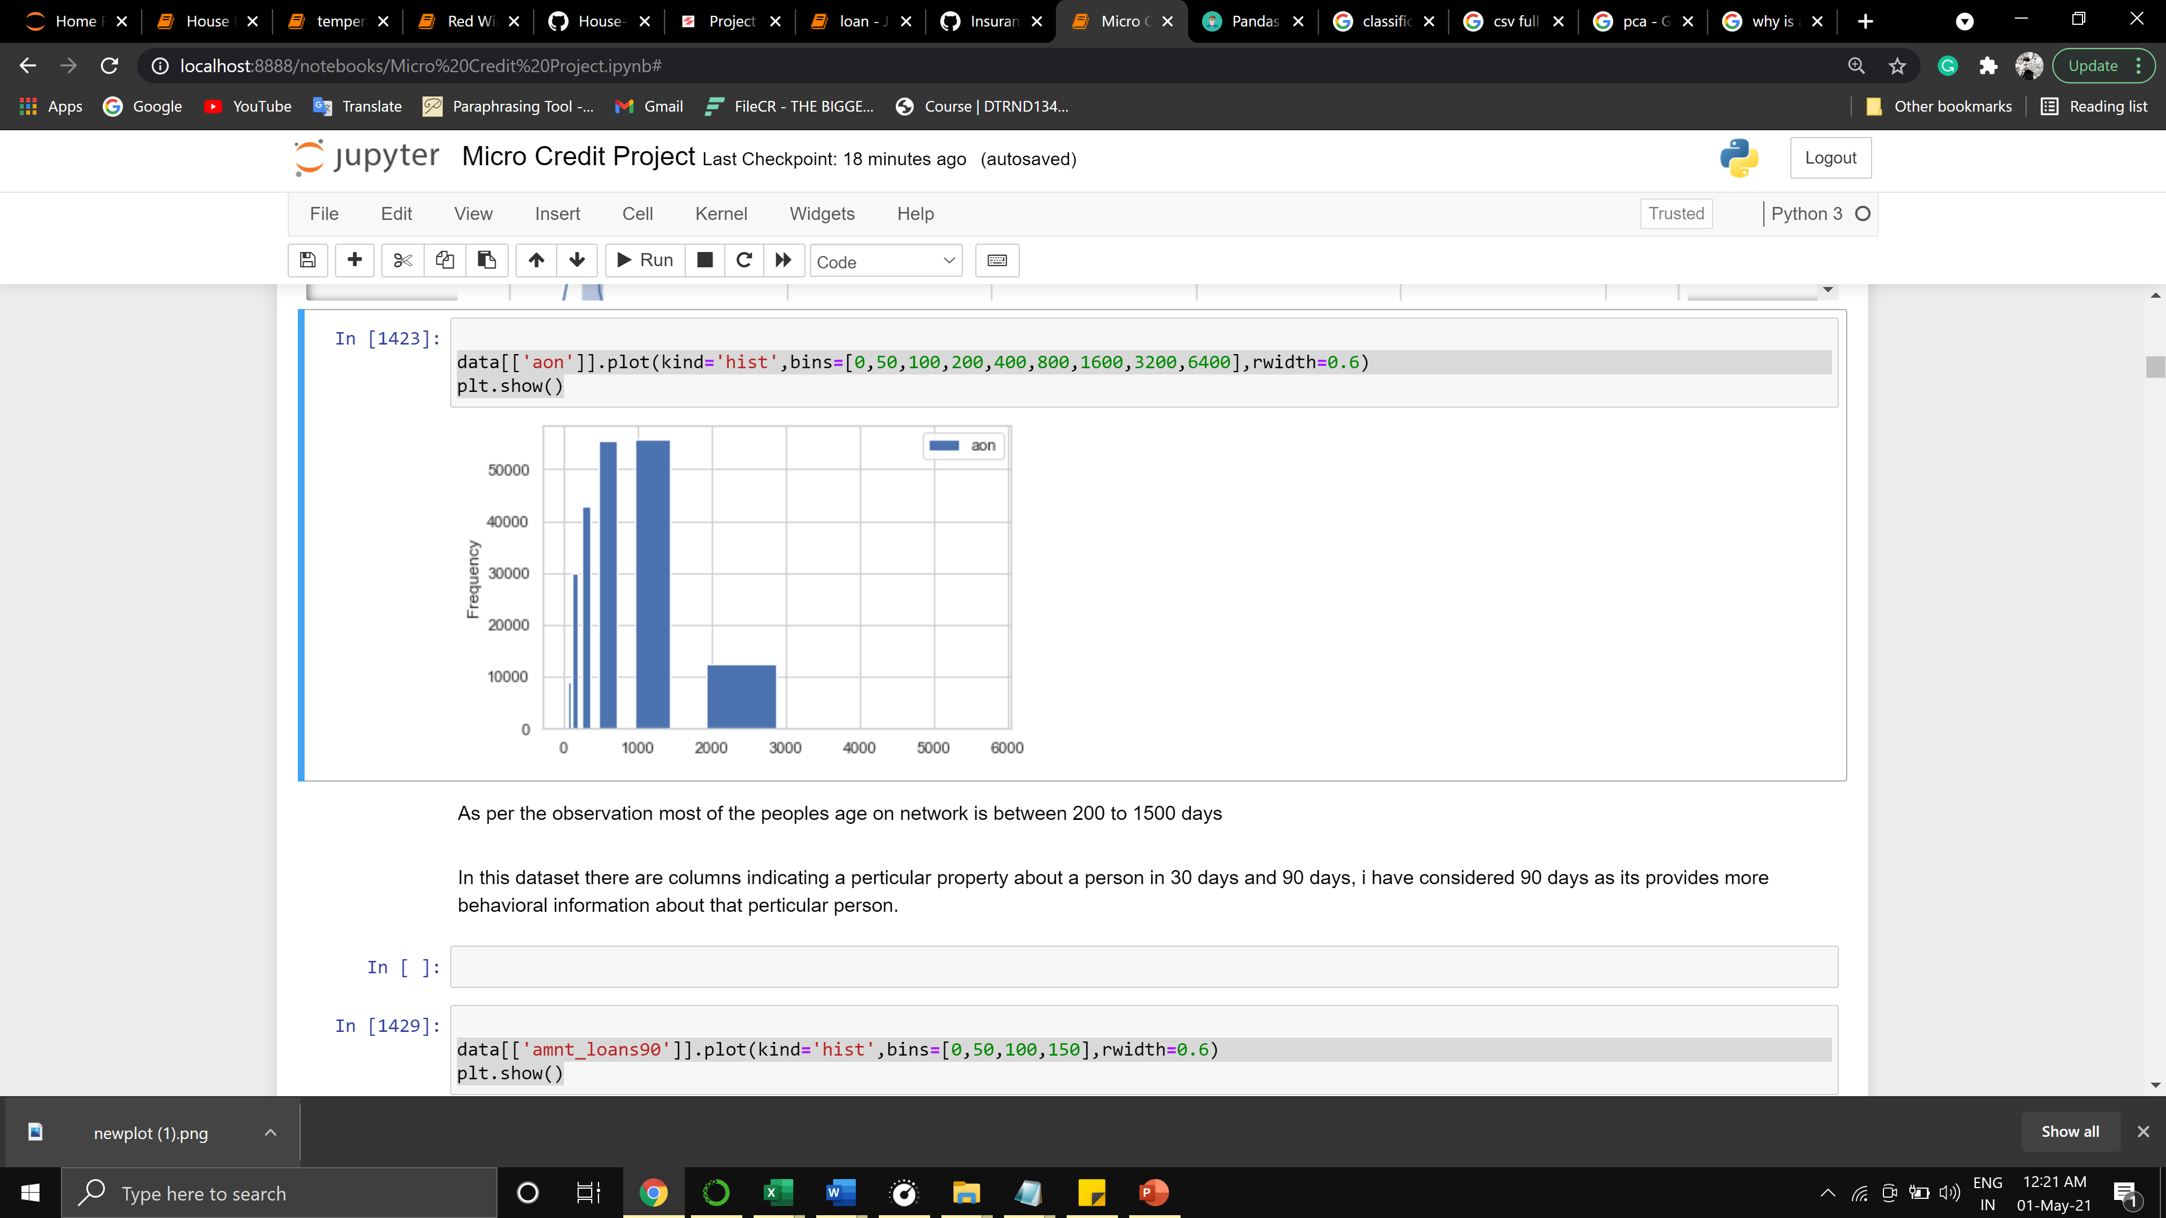

As per the observation, most of the people's age on the network is between 200 to 1500 days. In this dataset, columns are indicating a particular property about a person in 30 days and 90 days, I have considered 90 days as it provides more behavioral information about that particular person.

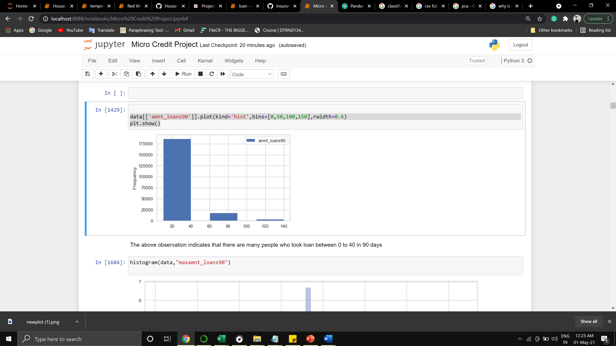

The above observation indicates that many people took loan between 0 to 40 in 90 days

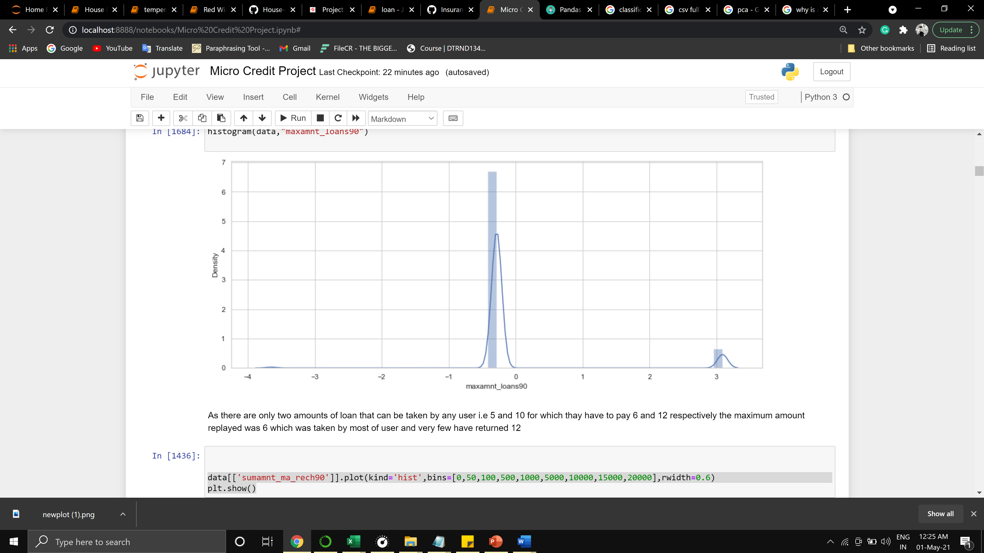

As there are only two amounts of loan that can be taken by any user i.e 5 and 10 for which they have to pay 6 and 12 respectively the maximum amount replayed was 6 which was taken by most of the user and very few have returned 12

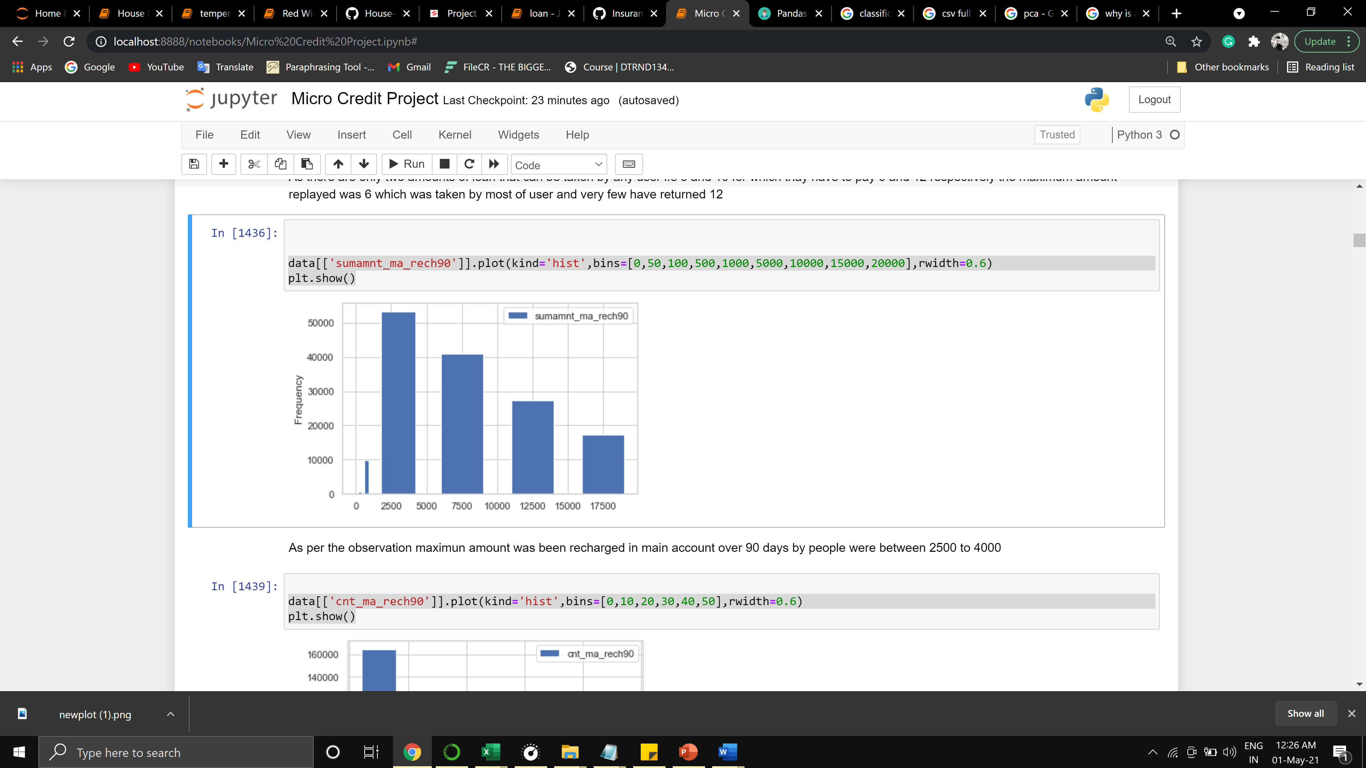

As per the observation maximum amount was been recharged in the main account over 90 days by people were between 2500 to 4000

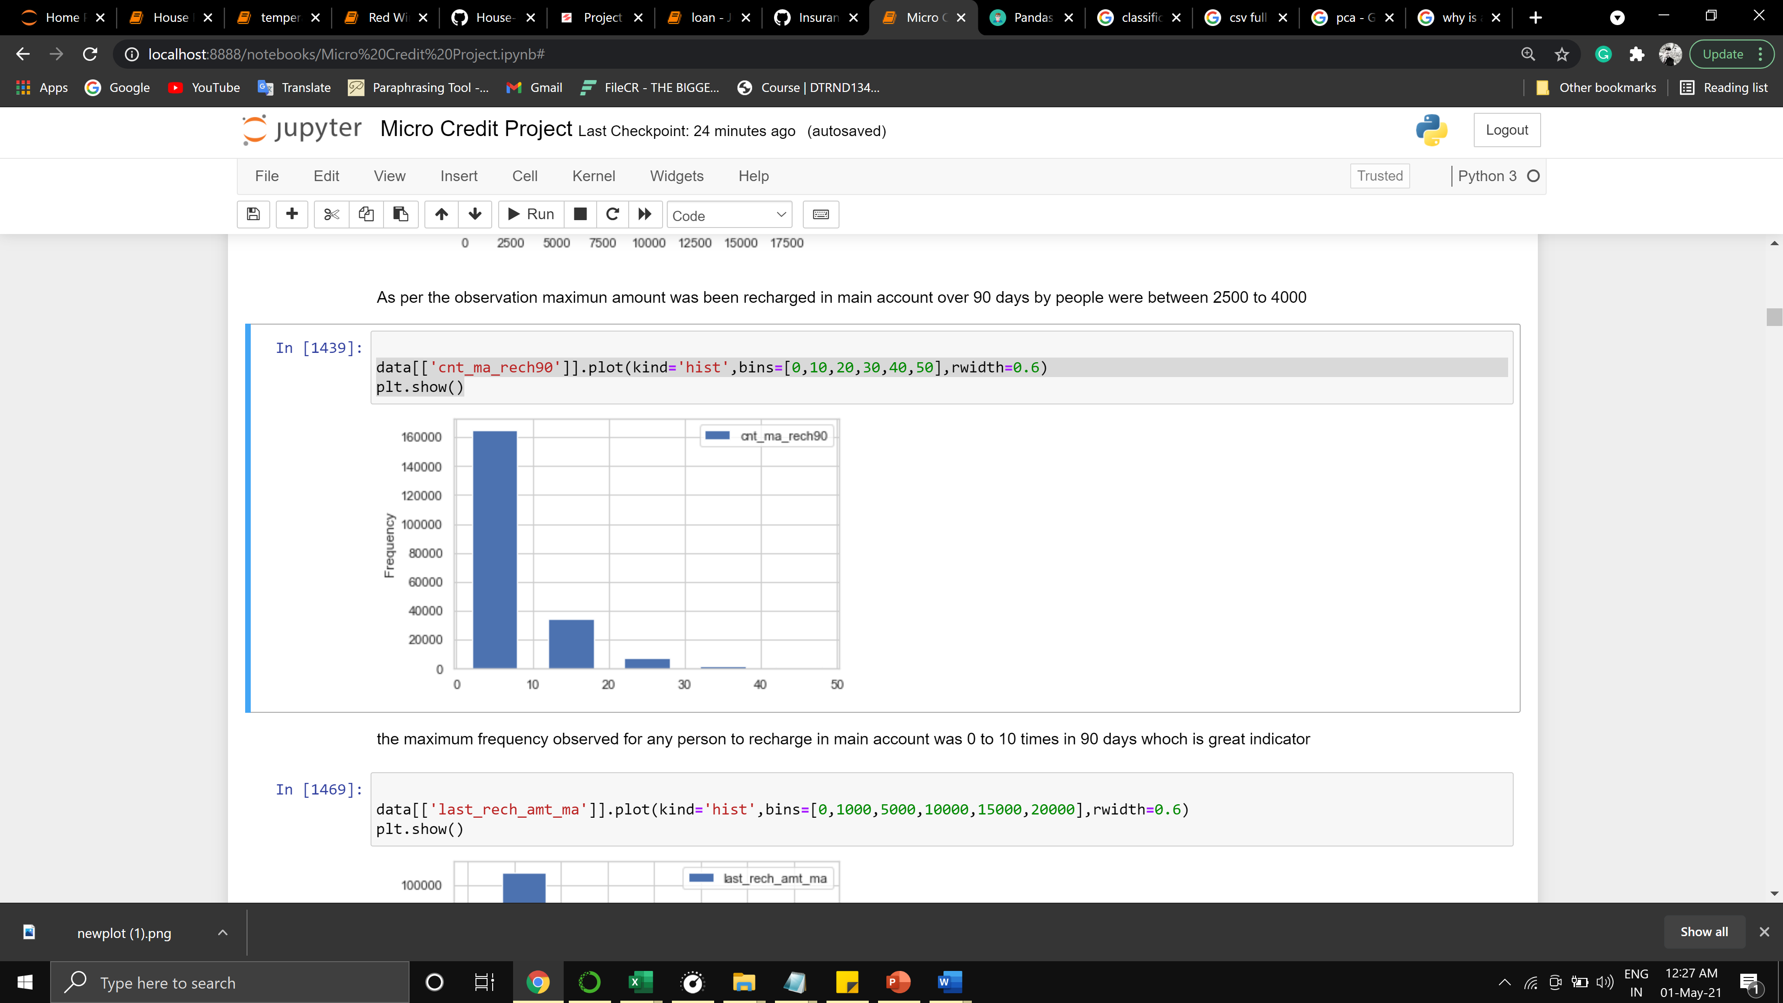

The maximum frequency observed for any person to recharge in the main account was 0 to 10 times in 90 days which is a great indicator

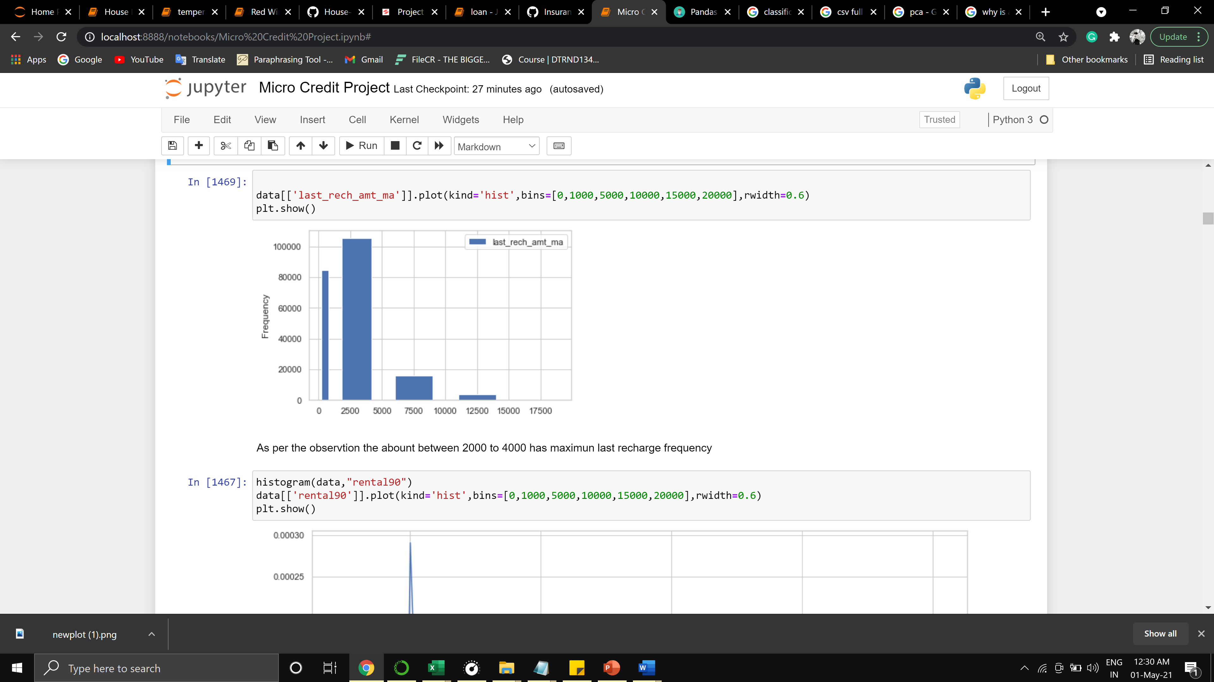

As per the observtion the abount between 2000 to 4000 has maximun last recharge frequency

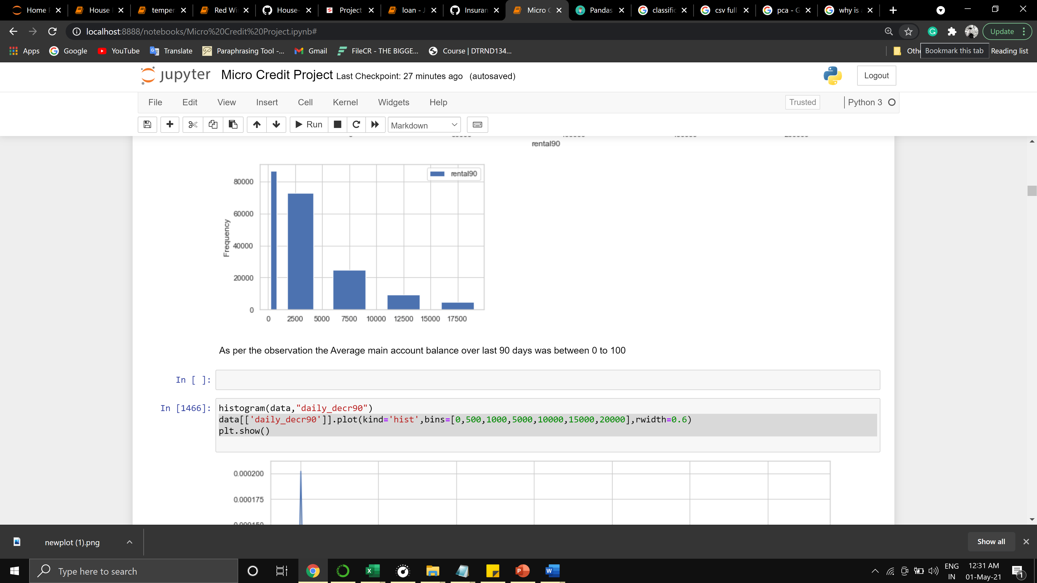

As per the observation the Average main account balance over last 90 days was between 0 to 100

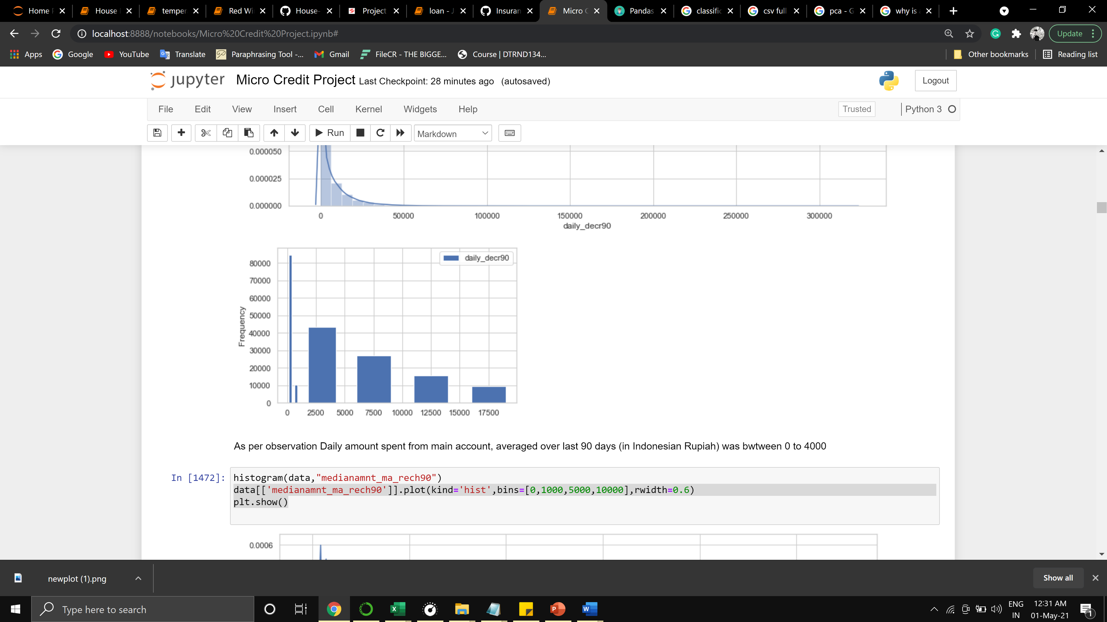

As per observation Daily amount spent from the main account, averaged over the last 90 days (in Indonesian Rupiah) was between 0 to 4000

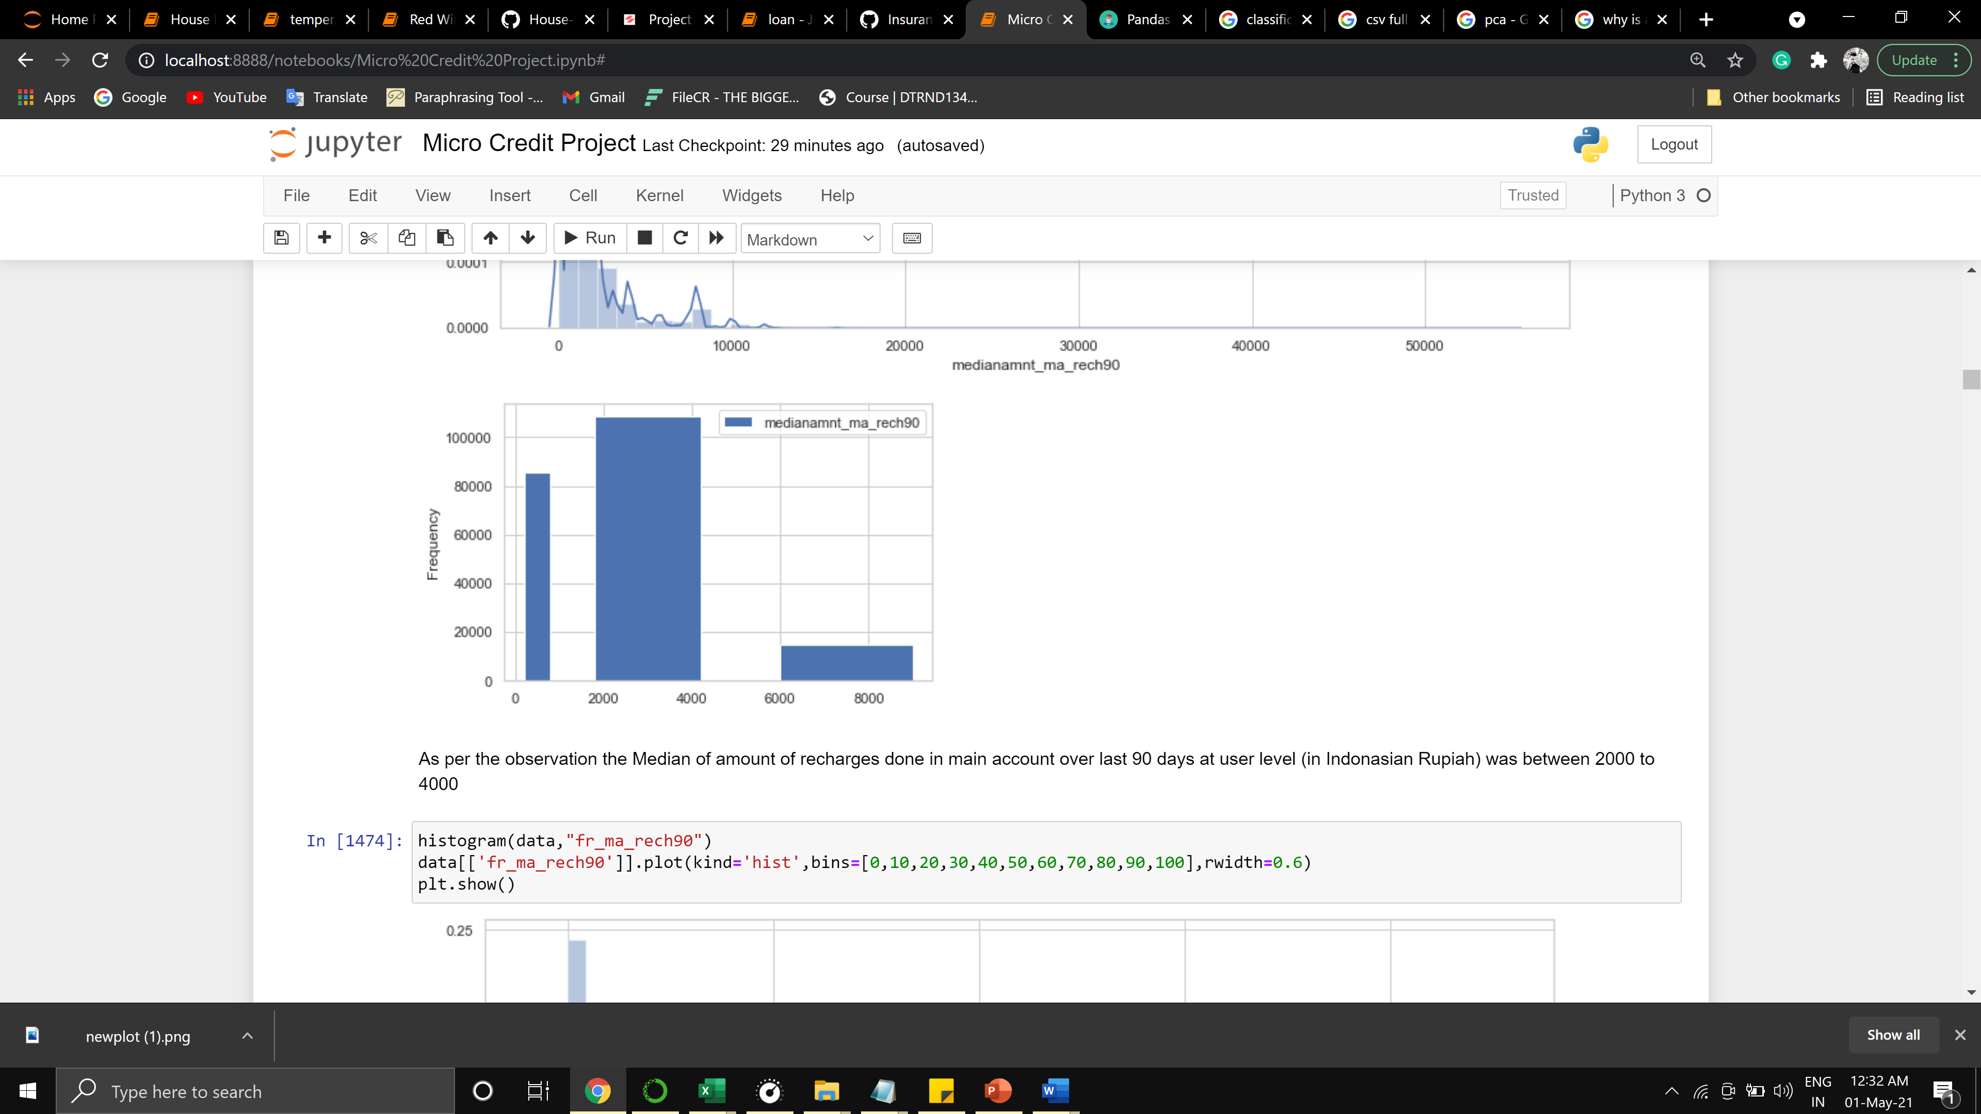

As per the observation, the Median amount of recharges done in the main account over the last 90 days at the user level (in Indonesian Rupiah) was between 2000 to 4000

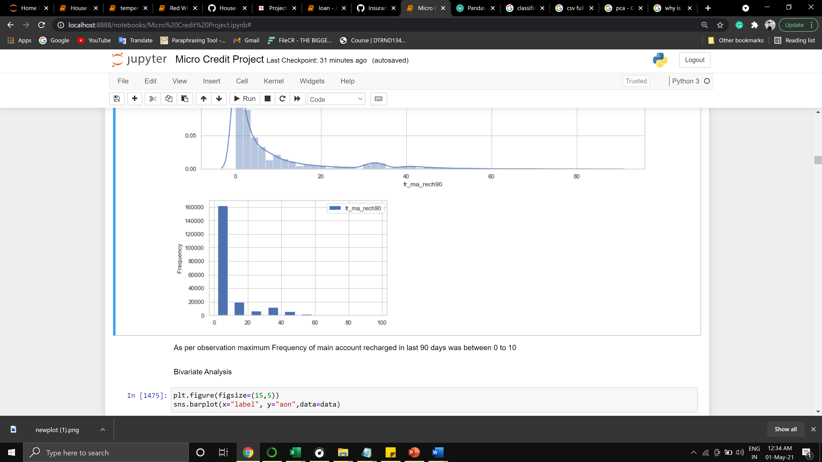

As per observation maximum Frequency of the main account recharged in the last 90 days was between 0 to 10

Bivariate analysis

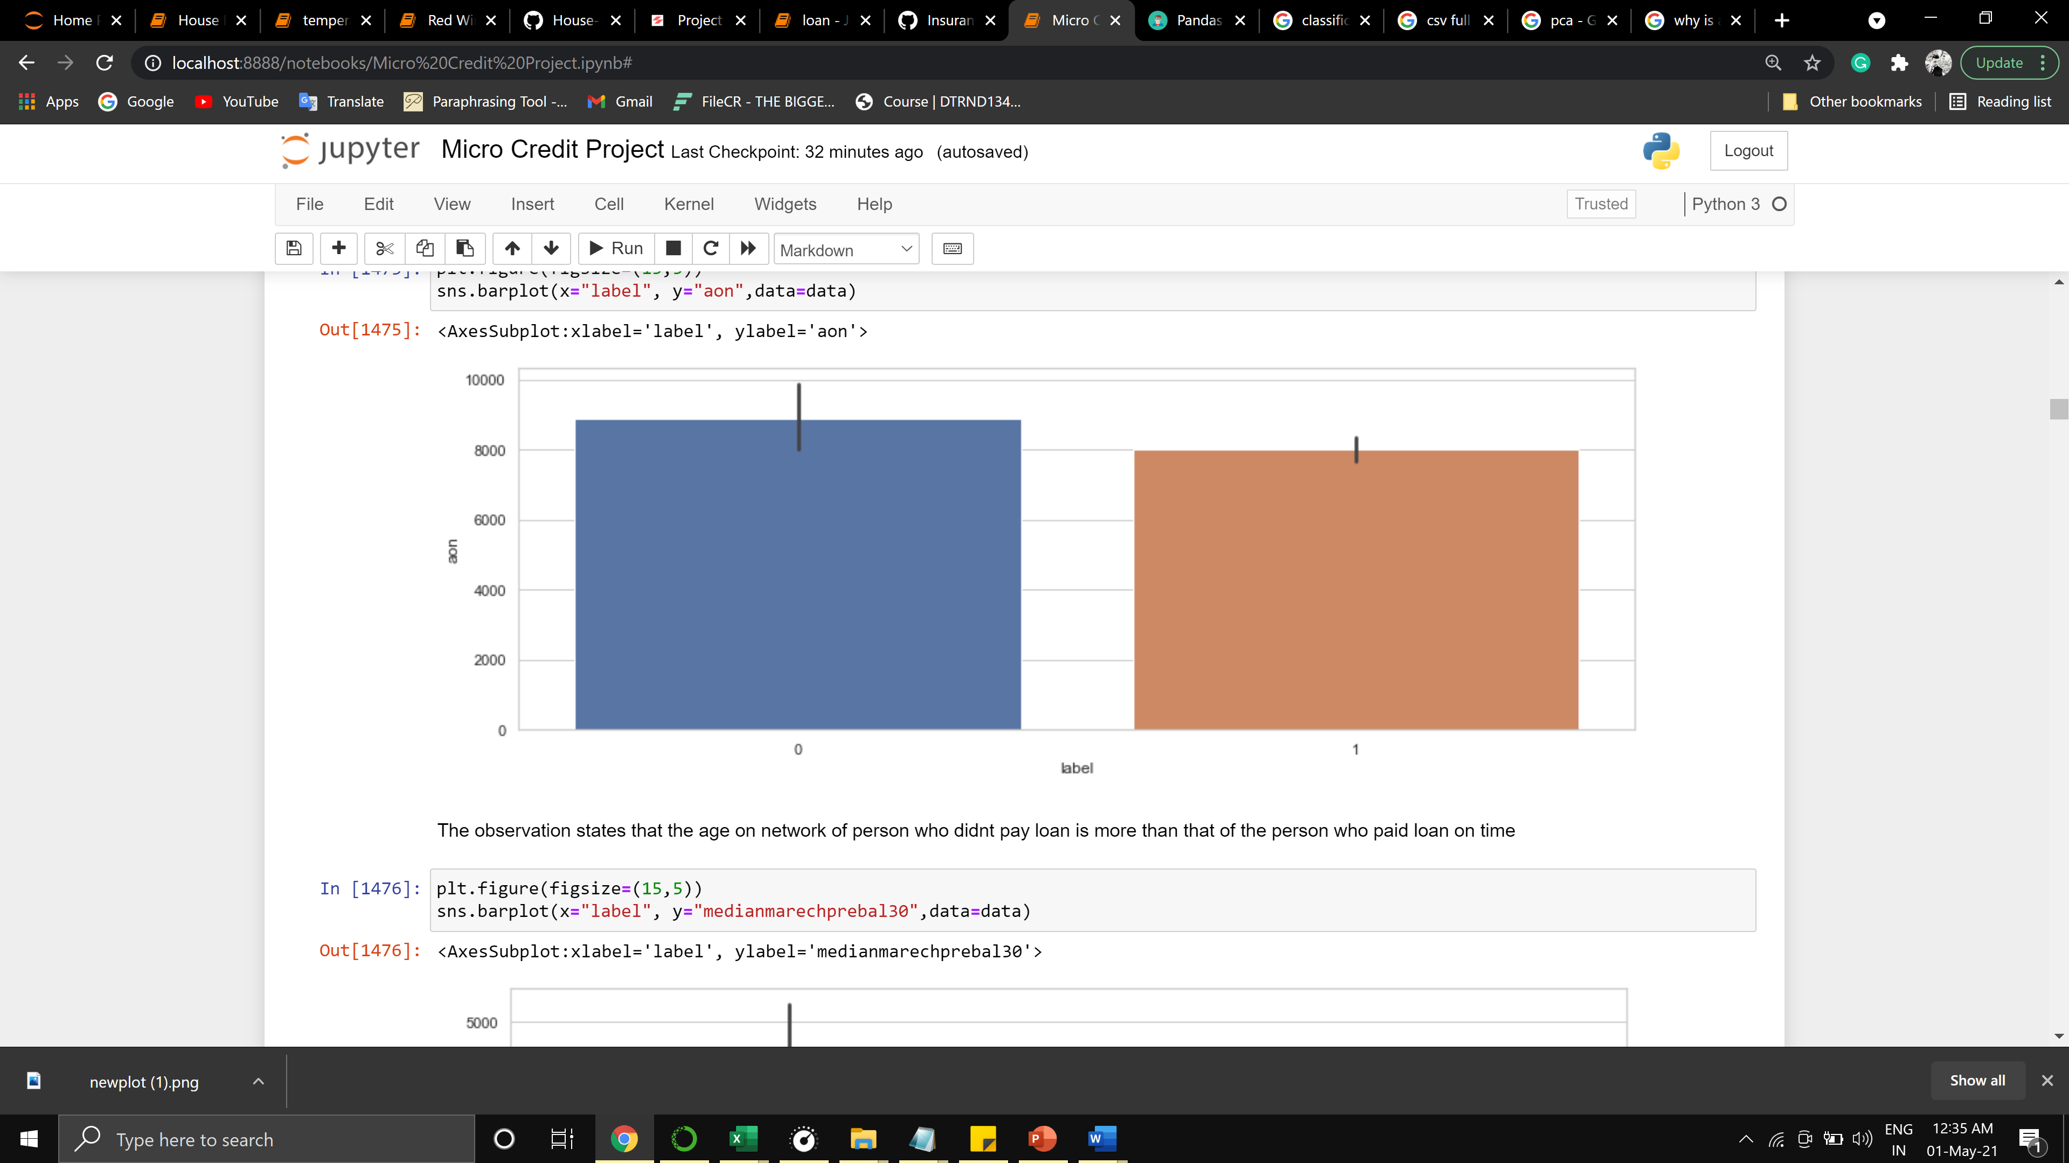

The observation states that the age on the network of person who didn't pay a loan is more than that of the person who paid the loan on time

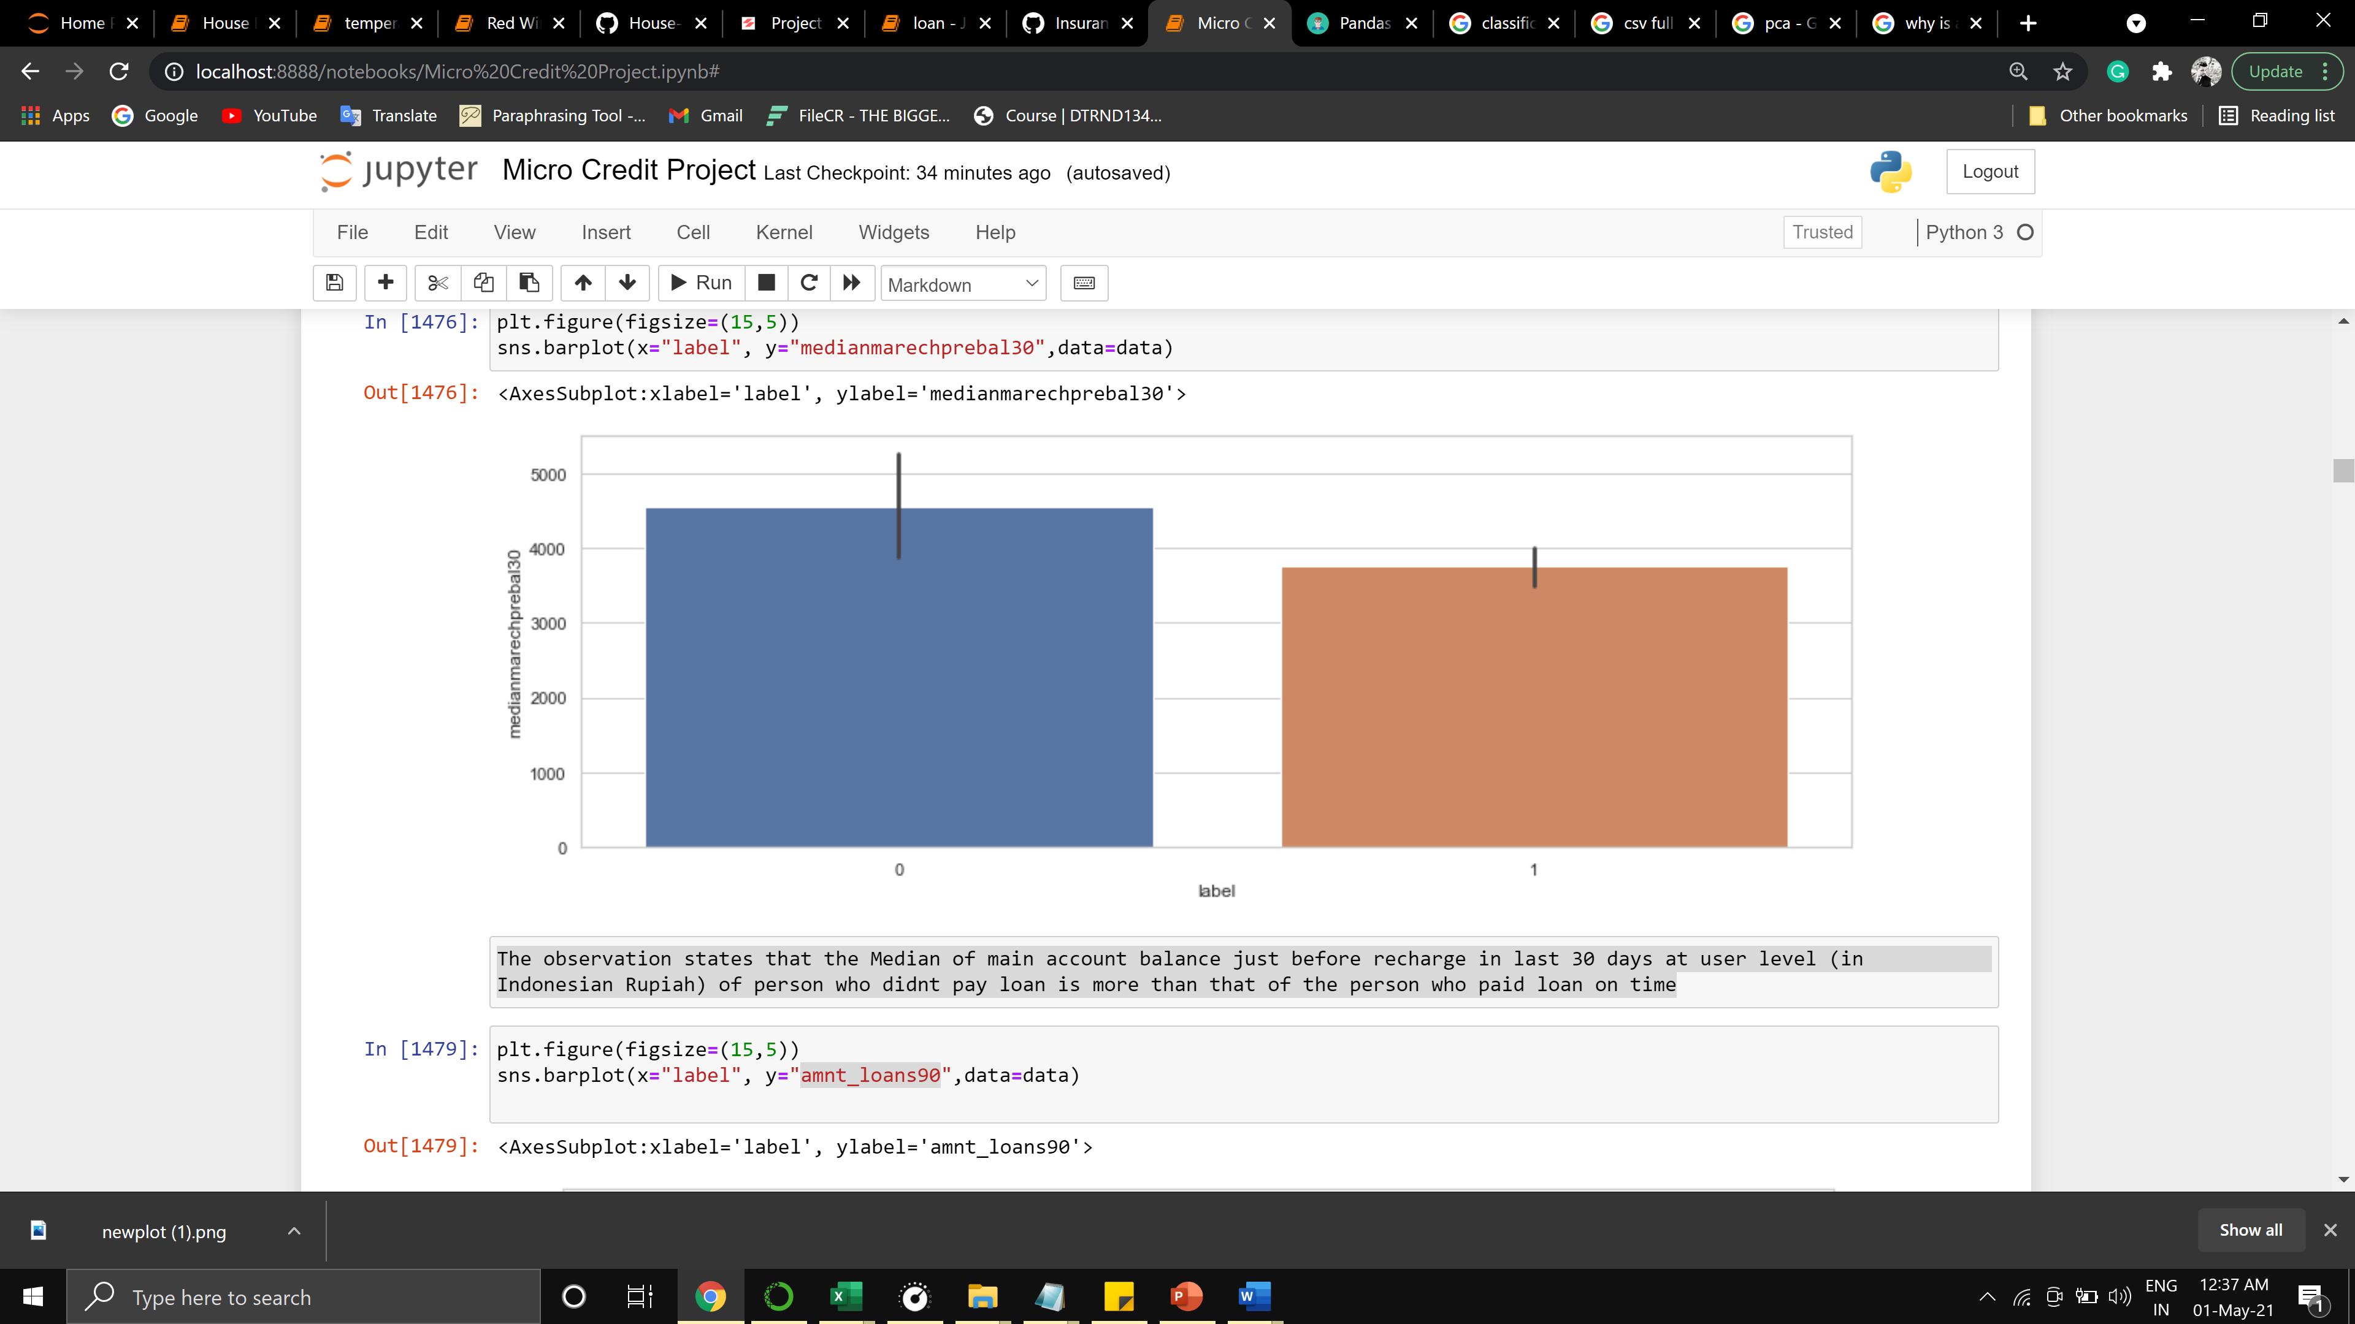

The observation states that the Median of the main account balance just before recharge in the last 30 days at the user level (in Indonesian Rupiah) of the person who didn't pay a loan is more than that of the person who paid the loan on time

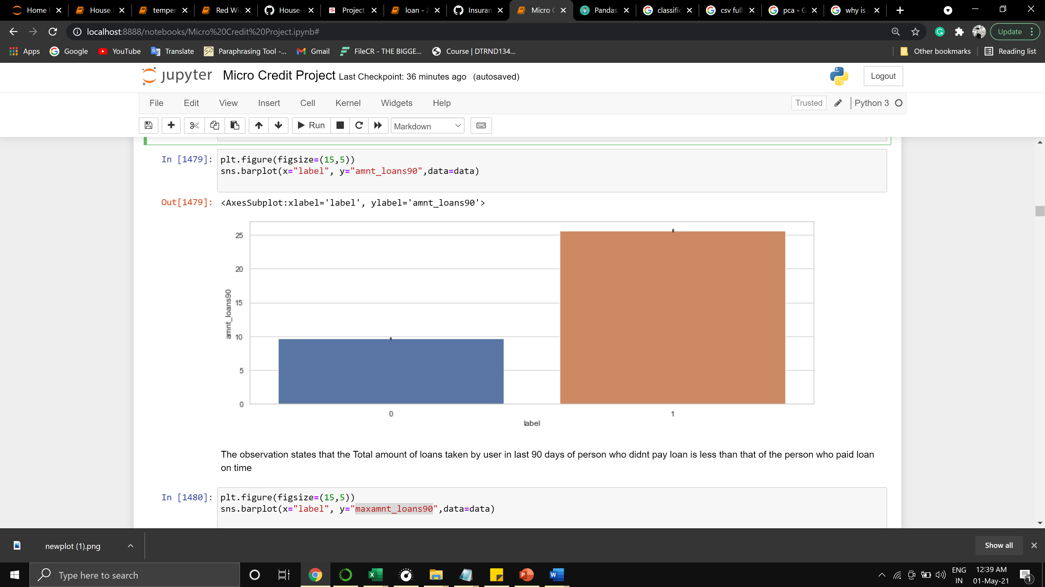

The observation states that the Total amount of loans taken by a user in the last 90 days of a person who didn't pay the loan is less than that of the person who paid the loan on time

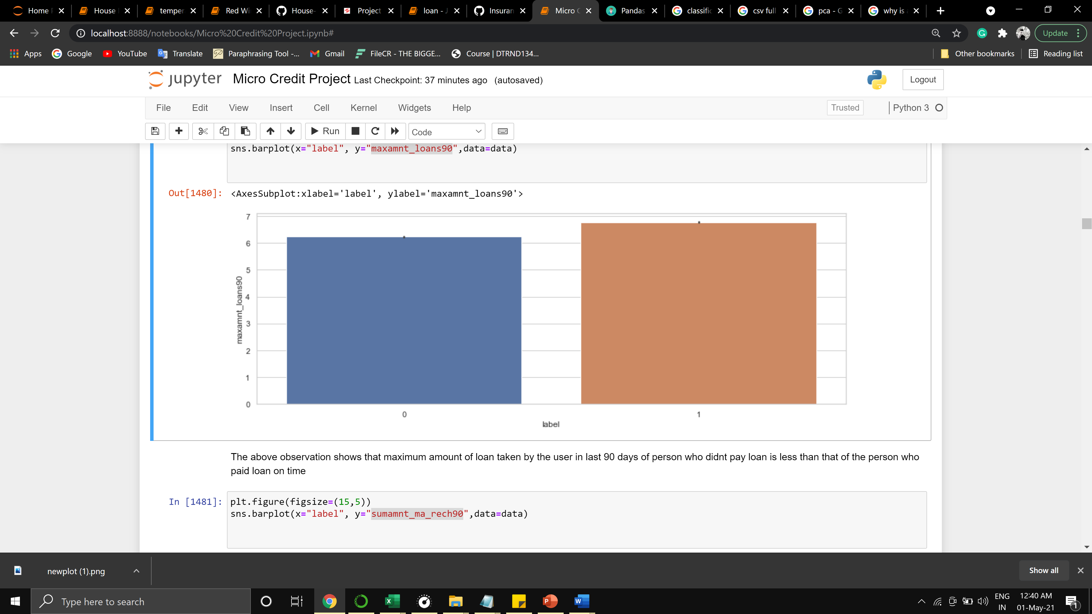

The above observation shows that the maximum amount of loan taken by the user in the last 90 days of a person who didn't pay a loan is less than that of the person who paid the loan on time

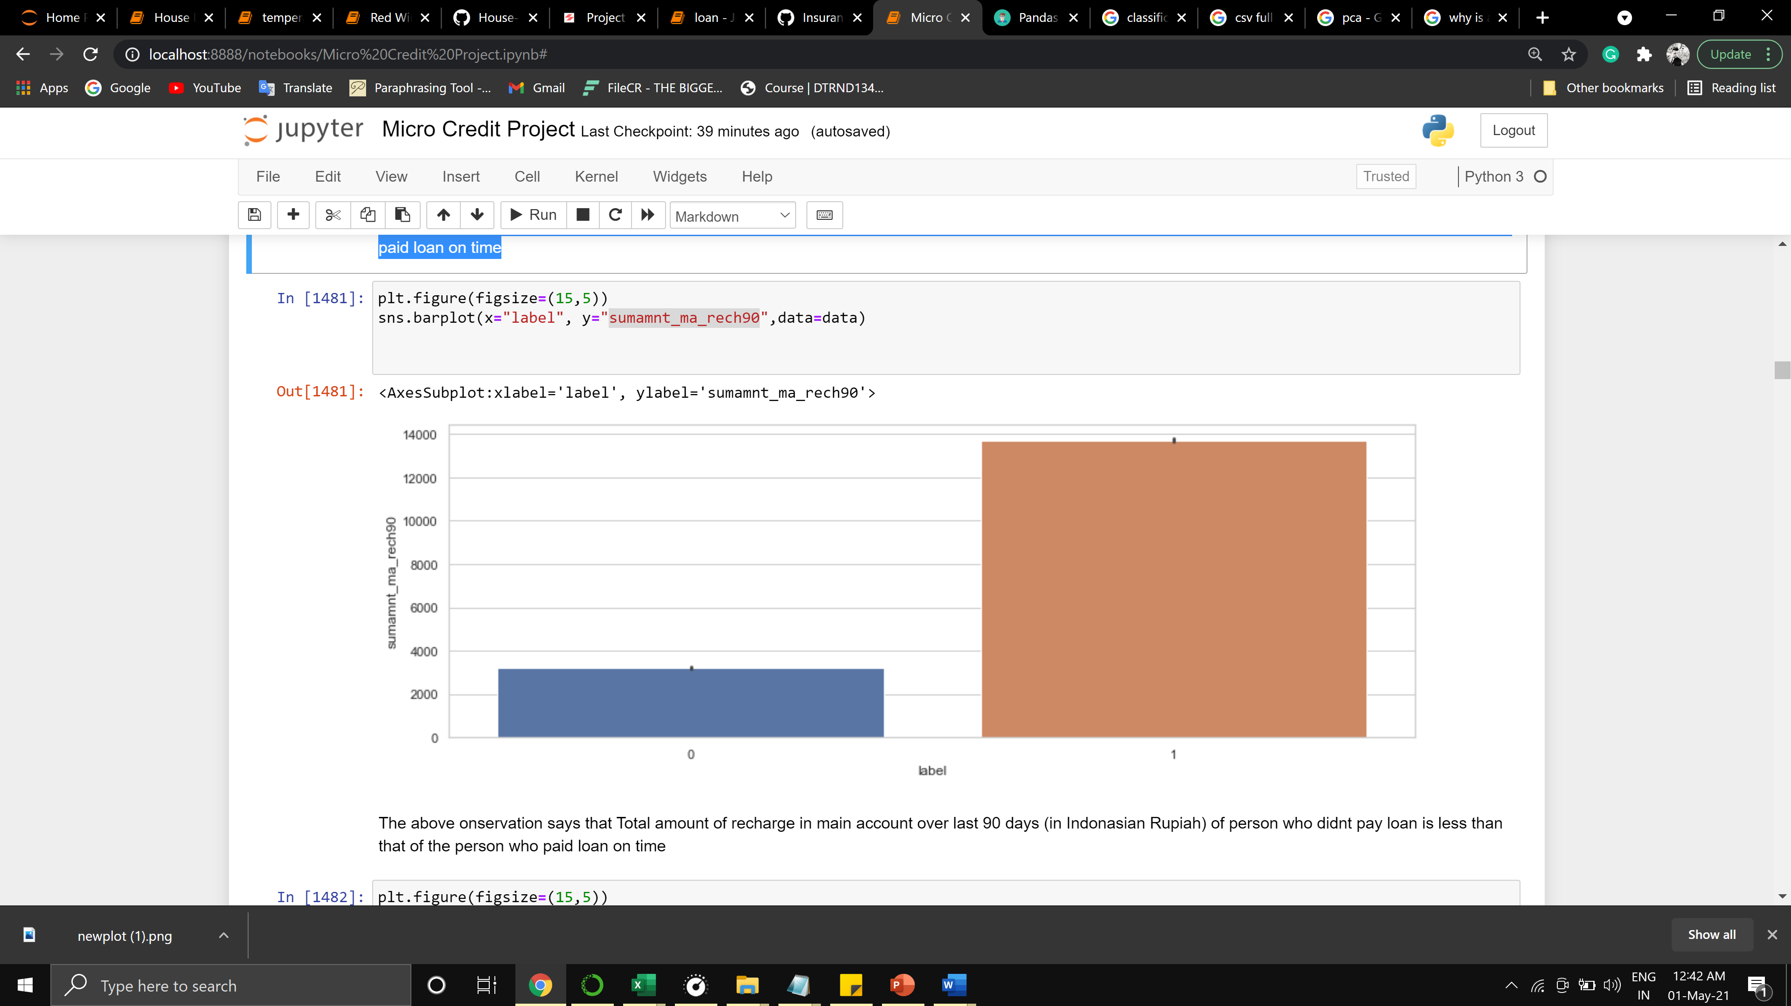

The above observation says that the Total amount of recharge in the main account over the last 90 days (in Indonesian Rupiah) of the person who didn't pay the loan is less than that of the person who paid the loan on time

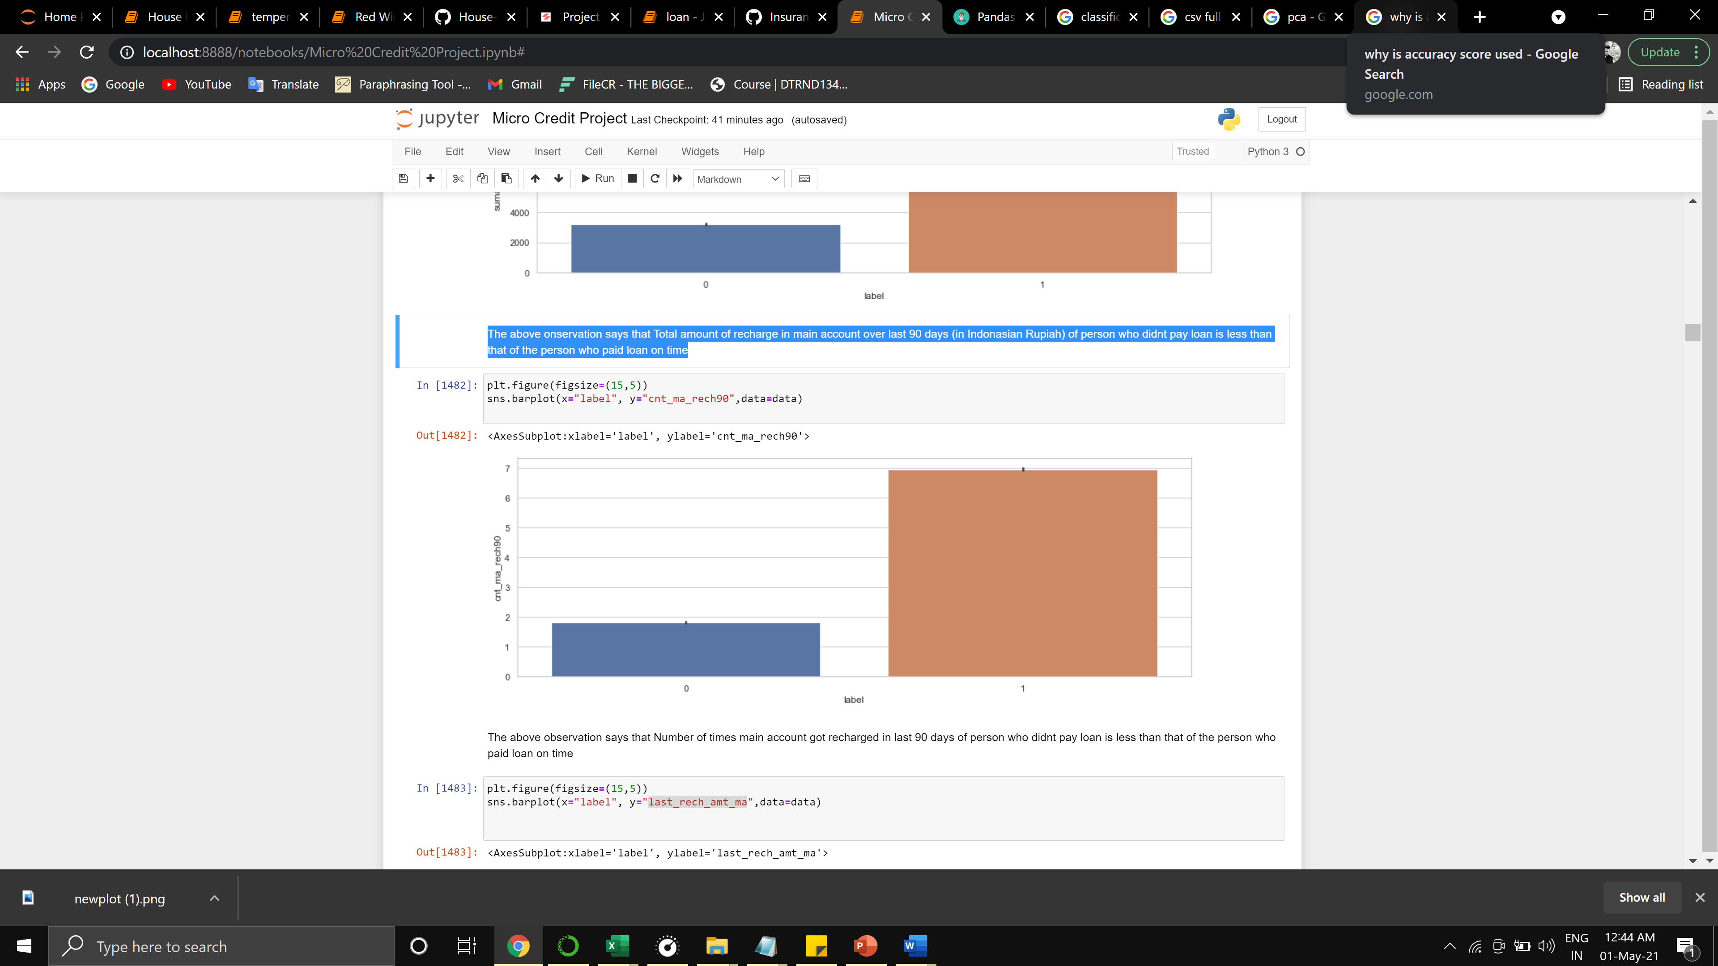

The above observation says that the number of times the main account got recharged in the last 90 days of a person who didn't pay the loan is less than that of the person who paid the loan on time

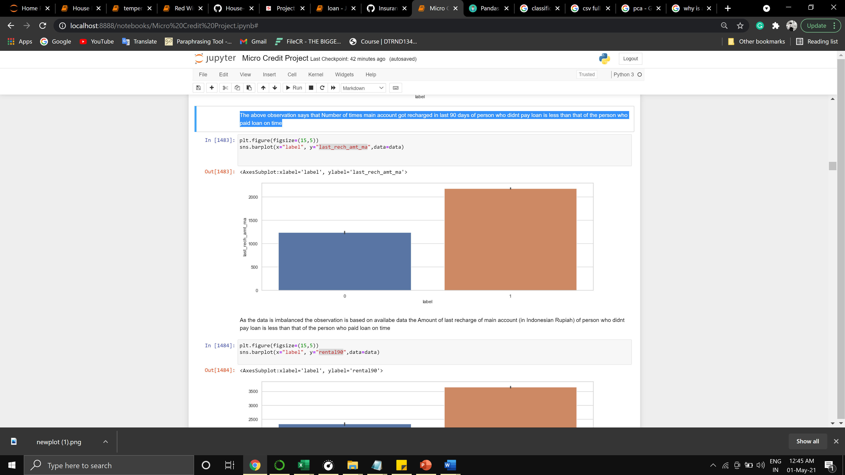

As the data is imbalanced the observation is based on availabe data the Amount of last recharge of main account (in Indonesian Rupiah) of person who didnt pay loan is less than that of the person who paid loan on time

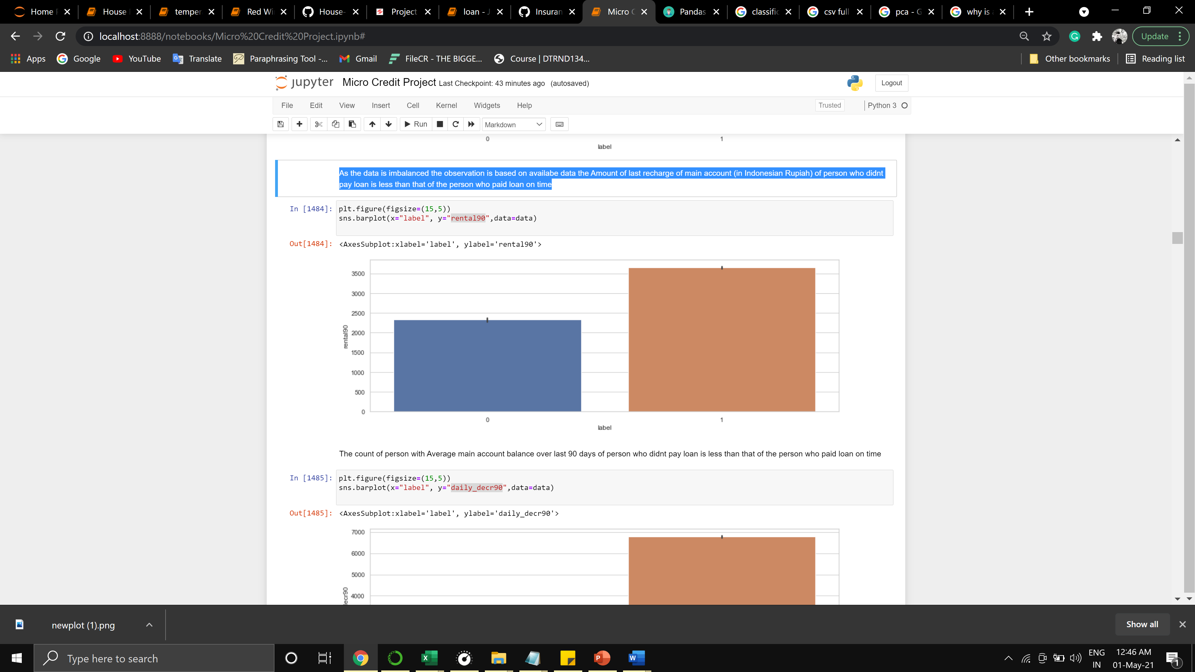

The count of a person with an Average main account balance over the last 90 days of a person who didn't pay the loan is less than that of the person who paid the loan on time

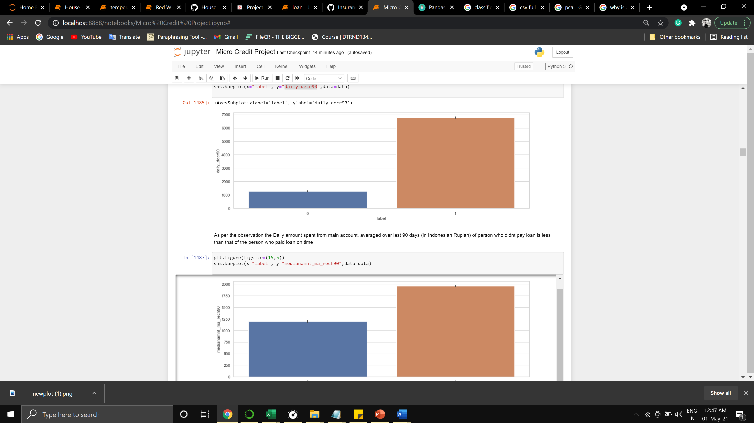

As per the observation the Daily amount spent from the main account, averaged over the last 90 days (in Indonesian Rupiah) of person who didn't pay the loan is less than that of the person who paid the loan on time

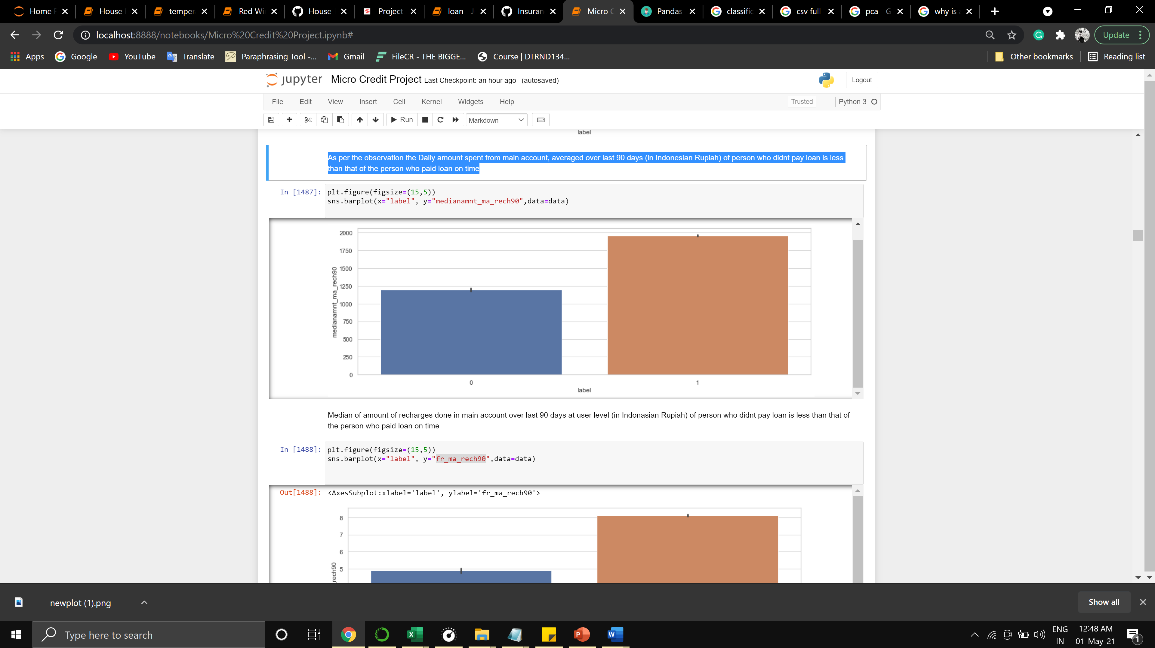

The median of the amount of recharges done in the main account over the last 90 days at the user level (in Indonesian Rupiah) of a person who didn't pay the loan is less than that of the person who paid the loan on time

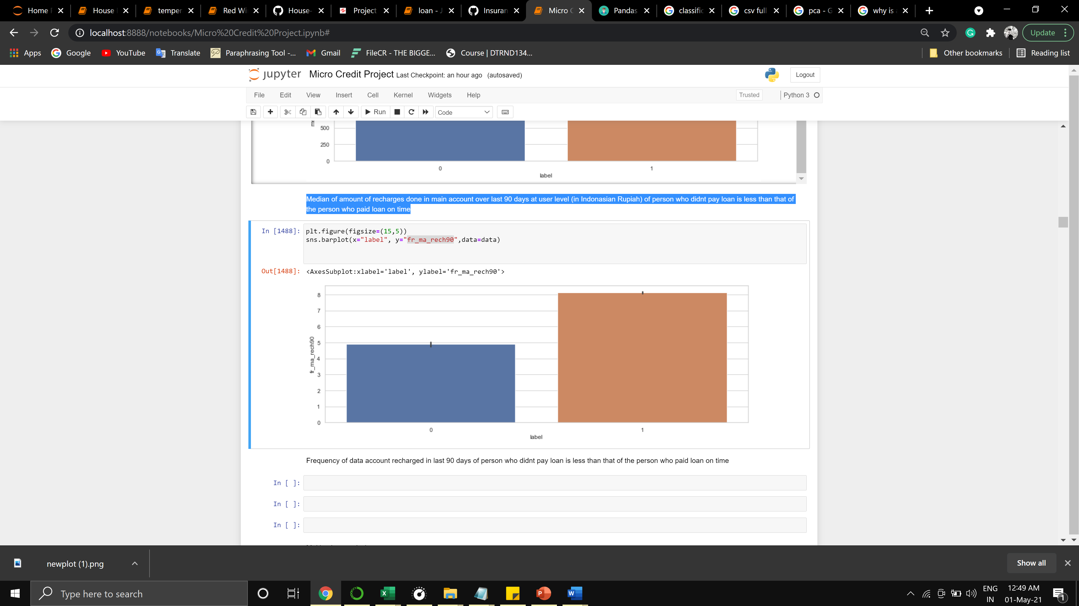

The frequency of data account recharged in the last 90 days of person who didn't pay the loan is less than that of the person who paid the loan on time

Multivariate analysis

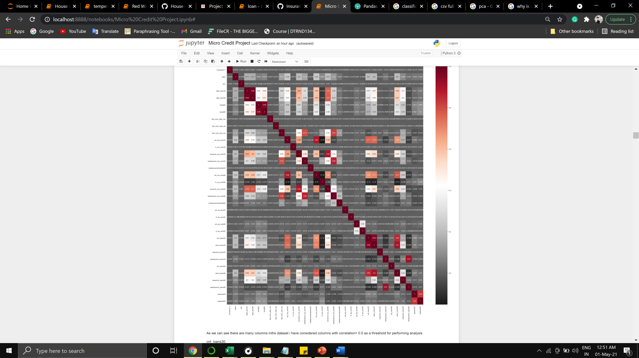

As we can see there are many columns inths dataset i have considered columns with correlation> 0.5 as a threshold for performing analysis

cnt_loans30

amnt_loans90

maxamnt_loans90

amnt_loans30

label

sumamnt_ma_rech90

cnt_ma_rech90

medianamnt_ma_rech30

sumamnt_ma_rech30

cnt_ma_rech30

last_rech_amt_ma

rental90

rental30

daily_decr90

daily_decr30

medianamnt_ma_rech90

fr_ma_rech90

These are the columns with higest correlation about 0.5 threshold

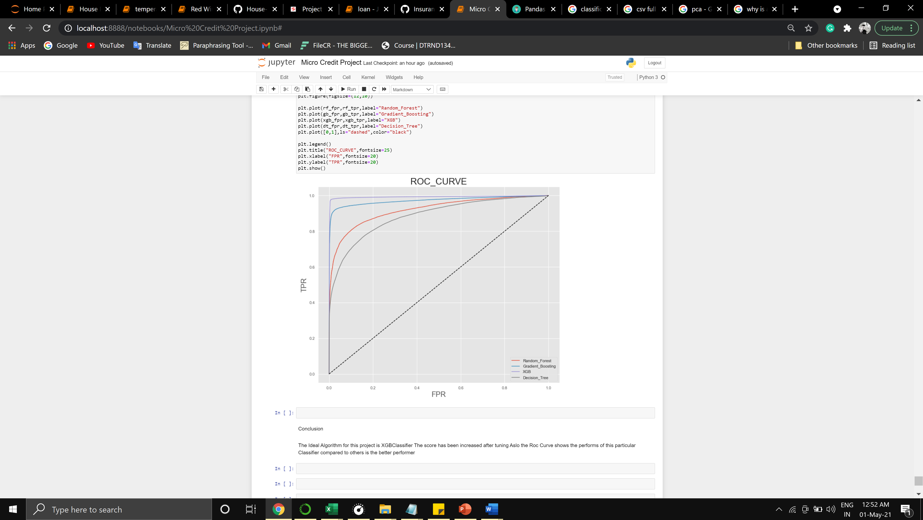

The Ideal Algorithm for this project is XGBClassifier The score has been increased after tuning Also the Roc Curve shows the performs of this particular Classifier compared to others is the better performer

**CONCLUSION**

* Key Findings and Conclusions of the Study

There are no null values in the dataset.

There may be some customers with no loan history.

The dataset is imbalanced. Label ‘1’ has approximately 87.5% records, while, label ‘0’ has approximately 12.5% records.

For some features, values are non-realistic.

There are outliers in some features.

The XGB performs better than other algorithms being used.

* Limitations of this work and Scope for Future Work

The limitation with data was sampling it was imbalanced so the optimum outcome wasn’t reached.

More algorithms can be tried along with better visualization.